### **Planning a Holiday Meal Project**

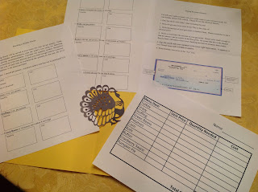

I love to apply math to real life situations. I created the following math project for my fourth grade students. I have included all materials necessary to implement this project in the following PDF except for the grocery advertisements. (This information is also available online because most grocery stores post their advertisements online). I also created a .Studio file of a turkey silhouette. I cut out one turkey per student for their project.

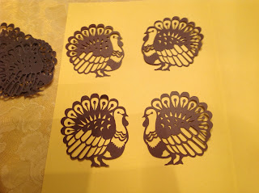

Planning a Holiday Meal

Thanksgiving dinner will be served at your home this year for ten people. Using the local supermarket advertisements, plan the meal’s cost using the following menu and serving recommendations. Calculate the quantity needed. Remember you need to round up to the next amount since you need enough food for everyone. Calculate the cost of each item by multiplying the quantity by the cost. Do all of your calculations in the space provided and circle your answer.

Serving recommendations:  
  
— Turkey: 1 pound per person  
— Gravy: 3 oz. per person   
— Stuffing: 1 oz. per person   
— Green Beans: 3 oz. per person  
— Potatoes: 1/2 lb. per person   
— Corn: 3 oz. per person   
— Rolls: 1 per person   
— Butter: 1 tsp. per person (96 tsp. in 1 lb. of butter)  
— Cranberry sauce: 14 oz. can has 5 servings   
— Pumpkin Pie: a 9-inch pie can be cut into 8 slices

Transfer your quantity and cost calculations to the “Planning a Holiday Dinner” table.  
  
Calculate the total cost of the meal by adding up all of the items to be purchased in the “Planning a Holiday Dinner” table. Write the total cost in the table.  
  
Write a check for the total cost of the meal.  
  
Cut out a picture of each item, if available, with the price from your grocery advertisement. Using a piece of construction paper, decorate your project with these pictures. Cut out the check and attach it your project along with the “Planning a Holiday Dinner” table. You may create this project in a book format or as a poster. When writing the check, the dollar amount is in word form, the cents are written as a number of cents over a hundred. For example. $135.45, is written as One Hundred Thirty Five 45/100 with a line going through the rest of the space.

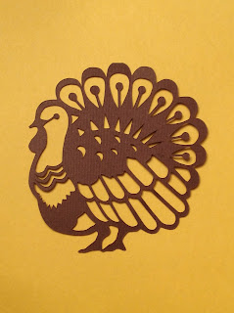

Happy Thanksgiving!